|  |  |  |
| --- | --- | --- |
| **Experiment No. : 3** | **Android UI** | **Date: 7/4/22** |

**AIM:** To design the User Interface of an Android Application

**Theory:**

**Changing Layout**

Android offers several layouts. **Linear Layout** (Vertical or Horizontal), and **Relative Layout**

(Grid). Simply right click on emulator and Select Change layout.

**Linear Layout:** Common for forms that display controls in a single row or column.

**Relative Layout:** Provides more flexibility in positioning controls

**Property Pane:** You can change properties of the object at run time or from the property pane. It is easier to use the Property Pane to change the object’s property.

**Adding Image**

To add image in android studio, simply drag and drop images in the drawable folder. And these images can be used in the Android Studio using **ImageView.**

The image from drawable can be directly displayed in the app using **setImageResource()** method.

**Setting Constraints**

Constraints can be added by dragging the given borders in the design panel or by writing the constraint in the Layout XML file.

**Types Of Constraints**

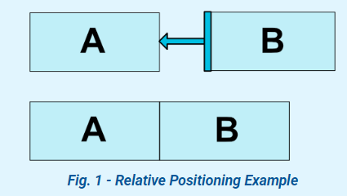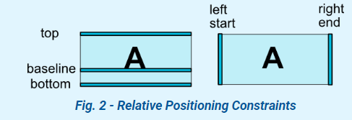

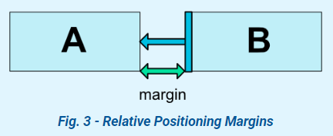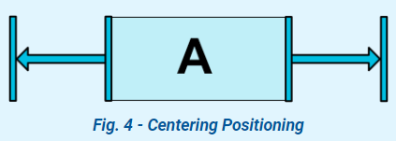

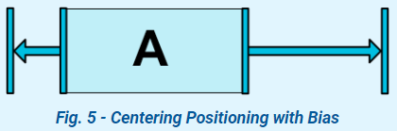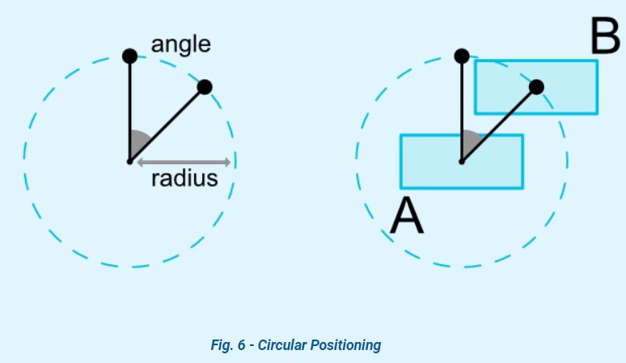

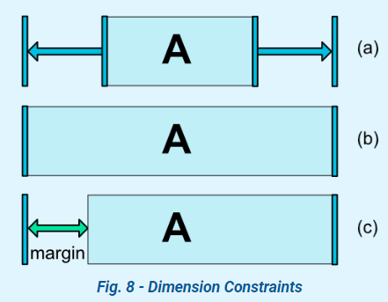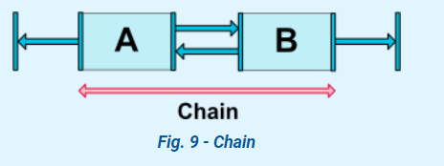

**Adding Button**

A button can be added by simply drag and drop method or by writing XML tag for buttons. Button size and colour can be specified as well as **onClick()** method can be created to define the action to be performed when the button is pressed.

**Adding TextView**

A TextView can be added by simply drag and drop method or by writing XML tag for TextView.

The desired text can be displayed using the **setText()** method.

**Adding EditText**

An EditText be added by simply drag and drop method or by writing XML tag for EditText.

The text typed inside the edit text can be accessed by using **getText()** method.

**Layout Code:**

<?xml version="1.0" encoding="utf-8"?>

<androidx.constraintlayout.widget.ConstraintLayout xmlns:android="http://schemas.android.com/apk/res/android"

xmlns:app="http://schemas.android.com/apk/res-auto"

xmlns:tools="http://schemas.android.com/tools"

android:layout_width="match_parent"

android:layout_height="match_parent"

tools:context=".MainActivity">

<TextView

android:id="@+id/rForm"

android:layout_width="wrap_content"

android:layout_height="wrap_content"

android:rotation="0"

android:rotationX="0"

android:rotationY="0"

android:scaleX="2"

android:scaleY="3"

android:text="Android UI"

app:layout_constraintBottom_toBottomOf="parent"

app:layout_constraintEnd_toEndOf="parent"

app:layout_constraintHorizontal_bias="0.498"

app:layout_constraintLeft_toLeftOf="parent"

app:layout_constraintRight_toRightOf="parent"

app:layout_constraintStart_toStartOf="parent"

app:layout_constraintTop_toTopOf="parent"

app:layout_constraintVertical_bias="0.035" />

<Button

android:id="@+id/btn"

android:layout_width="wrap_content"

android:layout_height="wrap_content"

android:onClick="onClick"

android:scaleX="1.5"

android:scaleY="1.5"

android:text="Submit"

app:layout_constraintBottom_toBottomOf="parent"

app:layout_constraintEnd_toEndOf="parent"

app:layout_constraintHorizontal_bias="0.537"

app:layout_constraintStart_toStartOf="parent"

app:layout_constraintTop_toBottomOf="@+id/rForm"

app:layout_constraintVertical_bias="0.489" />

<EditText

android:id="@+id/uname"

android:layout_width="220dp"

android:layout_height="50dp"

android:ems="10"

android:hint="Enter Full Name"

android:inputType="textPersonName"

android:textAlignment="center"

app:layout_constraintBottom_toBottomOf="parent"

app:layout_constraintEnd_toEndOf="parent"

app:layout_constraintHorizontal_bias="0.518"

app:layout_constraintStart_toStartOf="parent"

app:layout_constraintTop_toTopOf="parent"

app:layout_constraintVertical_bias="0.118" />

<EditText

android:id="@+id/umail"

android:layout_width="214dp"

android:layout_height="41dp"

android:ems="10"

android:hint="Enter Email"

android:inputType="textPersonName"

android:textAlignment="center"

app:layout_constraintBottom_toTopOf="@+id/unum"

app:layout_constraintEnd_toEndOf="parent"

app:layout_constraintHorizontal_bias="0.5"

app:layout_constraintStart_toStartOf="parent"

app:layout_constraintTop_toBottomOf="@+id/uname"

app:layout_constraintVertical_bias="0.44" />

<EditText

android:id="@+id/unum"

android:layout_width="220dp"

android:layout_height="50dp"

android:layout_marginBottom="48dp"

android:ems="10"

android:hint="Enter Mobile Number"

android:inputType="textPersonName"

android:textAlignment="center"

app:layout_constraintBottom_toTopOf="@+id/btn"

app:layout_constraintEnd_toEndOf="parent"

app:layout_constraintHorizontal_bias="0.518"

app:layout_constraintStart_toStartOf="parent" />

<TextView

android:id="@+id/txtView"

android:layout_width="273dp"

android:layout_height="86dp"

app:layout_constraintBottom_toBottomOf="parent"

app:layout_constraintEnd_toEndOf="parent"

app:layout_constraintStart_toStartOf="parent"

app:layout_constraintTop_toBottomOf="@+id/btn"

app:layout_constraintVertical_bias="0.029" />

<ImageView

android:id="@+id/pspImg"

android:layout_width="97dp"

android:layout_height="102dp"

app:layout_constraintBottom_toBottomOf="parent"

app:layout_constraintEnd_toEndOf="parent"

app:layout_constraintHorizontal_bias="0.171"

app:layout_constraintStart_toStartOf="parent"

app:layout_constraintTop_toTopOf="@+id/txtView"

app:layout_constraintVertical_bias="0.926" />

</androidx.constraintlayout.widget.ConstraintLayout>

**Layout Design:**

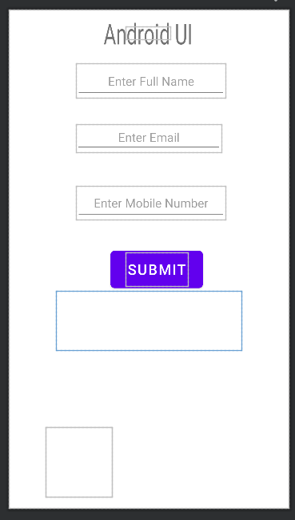

**Main Java Code:**

package com.ramanand.androidui;

import androidx.appcompat.app.AppCompatActivity;

import android.os.Bundle;

import android.view.View;

import android.widget.EditText;

import android.widget.ImageView;

import android.widget.TextView;

public class MainActivity extends AppCompatActivity {

@Override

protected void onCreate(Bundle savedInstanceState) {

super.onCreate(savedInstanceState);

setContentView(R.layout.activity_main);

}

public void onClick(View v){

EditText uName = findViewById(R.id.uname);

EditText uNum = findViewById(R.id.unum);

EditText uMail = findViewById(R.id.umail);

TextView textView = findViewById(R.id.txtView);

textView.setText("\nFull Name: "+uName.getText().toString()+"\n"+"Email: "+uMail.getText().toString()+"\n"+"Mobile Number: "+ uNum.getText().toString() );

ImageView imgV = findViewById(R.id.pspImg);

imgV.setImageResource(R.drawable.passportsize);

}

}

**Output**

1. Initial Screenshot

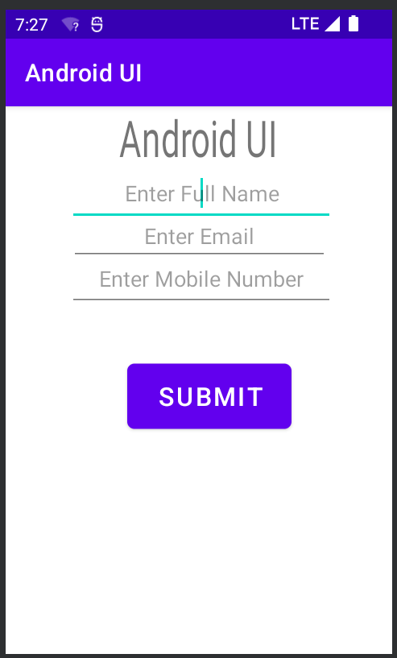

2. Screenshot After Filling the details

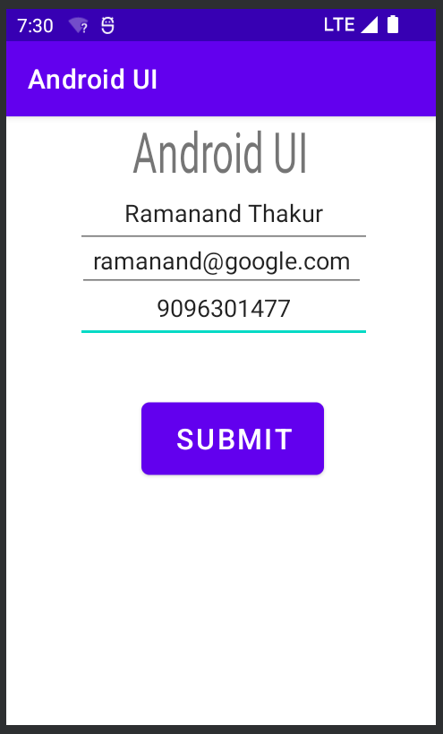

3. Screenshot After Clicking the SUBMIT Button

|  |  |  |
| --- | --- | --- |
| Agnel Institute of Technology & Design  Assagao, Goa.  Department of ECE | | |
| Programming | (2) |  |
| Execution & Result | (3) |  |
| Neatness | (2) |  |
| Viva | (3) |  |
| Total | (10) |  |
| Faculty In-charge sign |  |  |

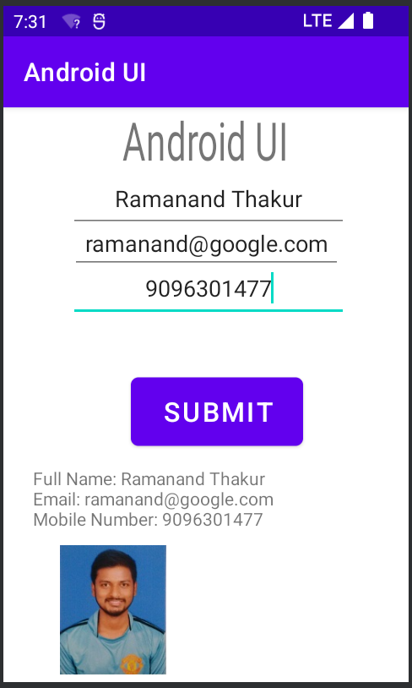

**Conclusion:** Various components of Android User Interface was successfully studied and an Android UI Application was successfully designed and tested.